|  |  |  |
| --- | --- | --- |
| **Report of** | **Meeting** | **Date** |
| **Director of Commercial** | **Scrutiny Committee** | **Tuesday, 12 October 2021** |

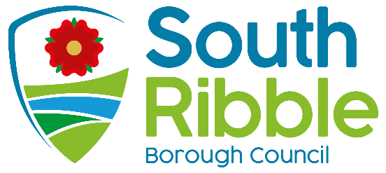

# Worden Hall Progress Report

|  |  |
| --- | --- |
| Is this report confidential? | No |

|  |  |
| --- | --- |
| Is this decision key? | No |

# Purpose of the Report

1. To provide members with a progress update on the Worden Hall project covering the following key elements  
   1. Main Contractor Appointment
   2. Engagement and Social Value
   3. Progress Since Last Meeting
   4. Financial
   5. Next Steps

## Recommendations to Scrutiny Committee

1. Members are asked to note the progress on project and the delivery programme.

## Reasons for recommendations

1. The completed scheme will re-establish Worden Hall as an important asset for the Council and the local community.

## Other options considered and rejected

## The Council could choose not to develop Worden Hall. This is not recommended as the Hall has the potential, with investment, to become an attractive asset which is highly valued by the community

## The Purcell and Amion report summarised a long list of options as part of a market review undertaken by Cushman and Wakefield on behalf of the Council in 2016 in order to select the three viable options for the financial appraisal. They discounted other options e.g. residential conversion, hotel, cultural attraction, or an independent retail space as being unviable.

## Feedback from the consultation survey in 2019 indicated that it was important to the public that the Council provided investment into Worden Hall as the status quo or do-nothing option was not acceptable.

## Corporate priorities

1. The report relates to the following corporate priorities: (please bold all those applicable):

|  |  |
| --- | --- |
| **An exemplary council** | **Thriving communities** |
| **A fair local economy that works for everyone** | **Good homes, green spaces, healthy places** |

## Background to the report

1. Worden Hall currently comprises of the main hall and a series of out buildings which are used by the South Ribble parks maintenance team and a number of small businesses. The main hall is currently unused except for a small area which is rented to a small café business (Folly Wood café).
2. In June 2018, the Council appointed consultants to undertake a feasibility study and options appraisal into the potential future uses of Worden Hall.
3. The consultant's report reviewed a number of options for the future use of the Hall which included looking at the investment costs of each option and the on-going revenue cost to the Council.
4. Only three options were considered viable and these formed the basis of the public consultation exercise. The three options included: 1. Community Use 2. A Small Wedding/Events Venue 3. An Exclusive Wedding/Events Venue
5. An extensive consultation exercise was undertaken from 19 August 2019 – 13 September 2019 with the public and key stakeholders to seek opinions on the future use of Worden Hall. This resulted in over 500 responses to the consultation survey. The preferred option was to deliver a hybrid facility that would deliver both community use and event space.
6. The outcome from the consultation was presented to Executive Cabinet on 16/10/2019 with the decision made to progress further detailed modelling and appraisal on the preferred option.
7. The preferred option was developed to RIBA Stage 3, with the planning application submitted in December 2020 and approved in March 2021.

## A picture containing grass, outdoor, building, house Description automatically generatedArchitect impression of Worden Hall Refurbishment

**Main Contractor Appointment**

1. A tender competition was held in accordance with the agreed procurement strategy which invited tenders from contractors on the Rise Construction framework. Three compliant tenders were received and the refurbishment works were awarded to John Turner Construction, a contractor based in Grimsargh near Preston.

**Engagement and Social Value**

1. On 12 August 2021 an “ask the architect” drop in event was held at Worden Hall which allowed members of the public to review the plans and ask any questions. The event was well attended and the feedback was generally very positive.
2. The appointed contractor John Turner construction have pledged a number of social value initiatives. A summary of these initiatives are provided below.

1. John Turner Construction would like to organise update tours and community workshop events for heritage construction techniques such as lime pointing and stone replacement.
2. John Turner would like to donate a bench to the park made by one of their own apprentices. A maze theme has been suggested to complement the Worden Park maze.
3. An update on these initiatives will be brought back to overview and scrutiny in the future.
4. In addition to the excellent social value offerings from john Turner, this scheme also benefits from the social value pledge from the Rise construction Framework where 25% of the framework fee will be fed back into a South Ribble community initiative.

**Progress Since Last Meeting**

1. The Folly Café were relocated to a temporary mobile café unit to allow the refurbishment works to be undertaken. Officers continue to work with the Folly Café tenants to discuss the new café space. The footfall to the temporary mobile unit has been very good.
2. Works commenced on site on 16 August 2021. The programmed completion date for the works is 22 May 2022. The site was secured with hoarding. The hoarding has been decorated with colourful graphics to promote the refurbishment and to provide wayfinding to the Folly café temporary unit and craft unit businesses.

Hoarding Graphics

1. The soft strip and mechanical and electrical strip out have been completed.
2. Demolition of the outbuilding and old conservatory has been undertaken under the supervision of an archaeologist and the infill of the old basement has been completed to allow the foundations for the new lift shaft and toilet block to be installed.
3. The condition of the brickwork is being assessed to confirm the pointing and cleaning requirements.

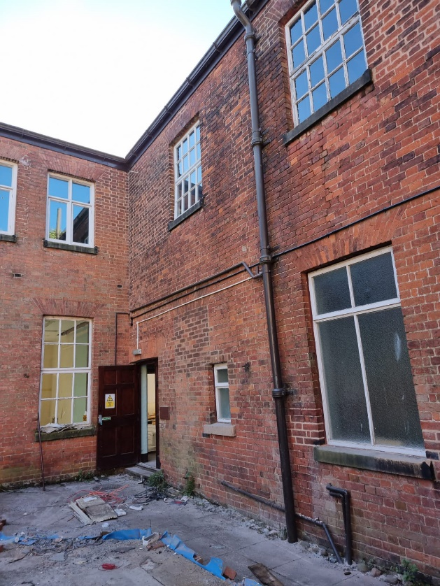

Area of the conservatory which has been demolished and location of new courtyard.

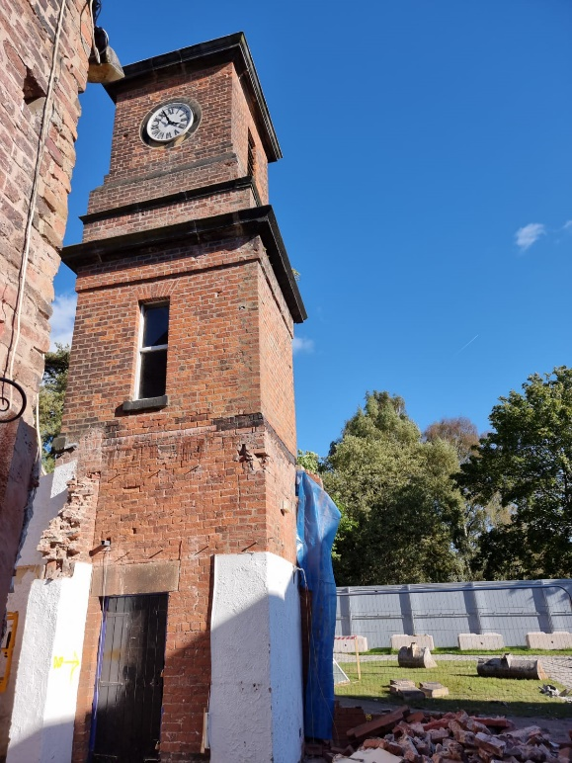

Demolition of old conservatory adjacent to clock tower.

Works progressing within Marsden Room.

1. The structure for the new museums, culture and tourism team that will take on operation of Worden Hall has now been approved and many of the posts are now filled. An internal working group is being set up with colleagues across the council who have an involvement in Worden Park to ensure the operation of the Hall works in tandem with other activities taking place and groups who use the park. That working group will help develop a detailed business case for the operation of the Hall in line with the principles of a community and events space that will attract more people into the borough. Enquiries for future use of the hall are being recorded.

**Next Steps**

1. Remedial works to windows.
2. Roof repair and replacement works.
3. Construction of new lift shaft and toilet block.
4. Construction of new plant room buildings.
5. Internal works to walls and floors.
6. Drainage repairs and new drainage
7. New incoming service supplies
8. Issue draft head of terms to Folly Café for agreement.
9. Finalise the interior design for the hall.

**Financial**

1. In July 2021 Council approved an increased budget of £2,915,000, which included a £250,000 risk contingency.

## Comments of the Statutory Finance Officer

## There are no direct financial implications relating to this report. The scheme is on track to be within the approved budget.

## Comments of the Monitoring Officer

## The report is for noting. There are no legal issues arising from this report.

## Climate change and air quality

1. Considered as part of the design development

## Equality and diversity

1. Considered as part of the design development.

## Risk

## Completion by Leyland Festival 2022 – detailed programme analysis and monitoring is being undertaken.

## Delay in delivery of materials. Early orders placed to mitigate this.

## Repair works more extensive than anticipated when uncovered.

Background documents

Overview and Scrutiny Report – 13 July 2021

## Appendices

None

|  |  |  |  |
| --- | --- | --- | --- |
| Report Author: | Email: | Telephone: | Date: |
| Rachel Salter (Project Manager, Service Lead (Development and Business)) | rachel.salter@southribble.gov.uk |  | 04/10/21 |